ESJ Submission Template:

All Manuscripts Should be Based on This Template

Introduction

This is a template for authors who wish to submit manuscripts to Educational Studies in Japan (ESJ). Use this template with reference to the ESJ Manuscript Submission Guidelines in each issue of ESJ and on the JERA website. The writing style of the manuscript, including fonts, font sizes and spacing, should follow this template. Headings are described in the table example (2.5.1). For points not covered in this template, please follow the latest edition of the Publication Manual of the American Psychological Association (APA style).
Title should be at the beginning of the first page in 14-point font. The subtitle (if any) should be prefixed by a colon <:>. In the title, all words except for articles, prepositions and conjunctions should begin with an uppercase letter. If the submission is a Research Note, please write [Research Note] over the title. For submissions to special issues, please add “Special Issue” at the beginning of the title.

Rules for Manuscript Preparation

2.1 Language
Articles should be written in English. Contributors whose native language is not English must have their manuscripts copyedited with the assistance of an English speaker of native-level proficiency.
If Japanese text (e.g. kokusaika) is included, the Japanese (and/or other non-English) words must be italicized, and care taken to ensure that the style and spelling of any such transcriptions are consistent throughout the manuscript.

2.2 Length
Research papers should be a maximum of 6,000 words long, including figures, tables, notes, and references. Research notes should be 2,000-3,000 words long.

2.3 Tables and Figures
Tables and figures should also be included in the text. If they do not fit in the main text file due to size or other reasons, upload them in a separate file (be sure to include the equivalent number of words therein). The word count of tables and figures should be calculated based on the size. Tables smaller than 1/4 of the printed image of the journal should be calculated as 150 words. Tables of 1/2 page size should be calculated as 300words, while full-page tables should be considered to be 600 words.

2.3.1 Tables
Each table should carry a complete title placed directly above the table, numbered in sequence with Arabic numerals (e.g., Table 1). Text in the table is preferred to be at least 9 pt so that it is legible when printed. Sources and other information should be listed below the table.

Table 1 Example: Three Levels of Heading in ESJ
Heading | Styles | Format
Level 1 | Arial, Bold | Leave a blank line before and after the heading; capitalize every first letter
1.1 Level 2 | Times New Roman, Bold | Leave a blank line before the heading; capitalize only the first letter
1.1.1 Level 3 | Times New Roman, Bold | Do not leave blank lines before or after headings; capitalize only the first letter
* Sources, etc. should be listed below the table.

2.3.2 Figures
For figures, the title position, font size, and other information is the same as for tables. Tables should be used rather than figures where possible, limiting figures to information that must be represented as figures.

Figure 1 Example: ESJ Editorial Process
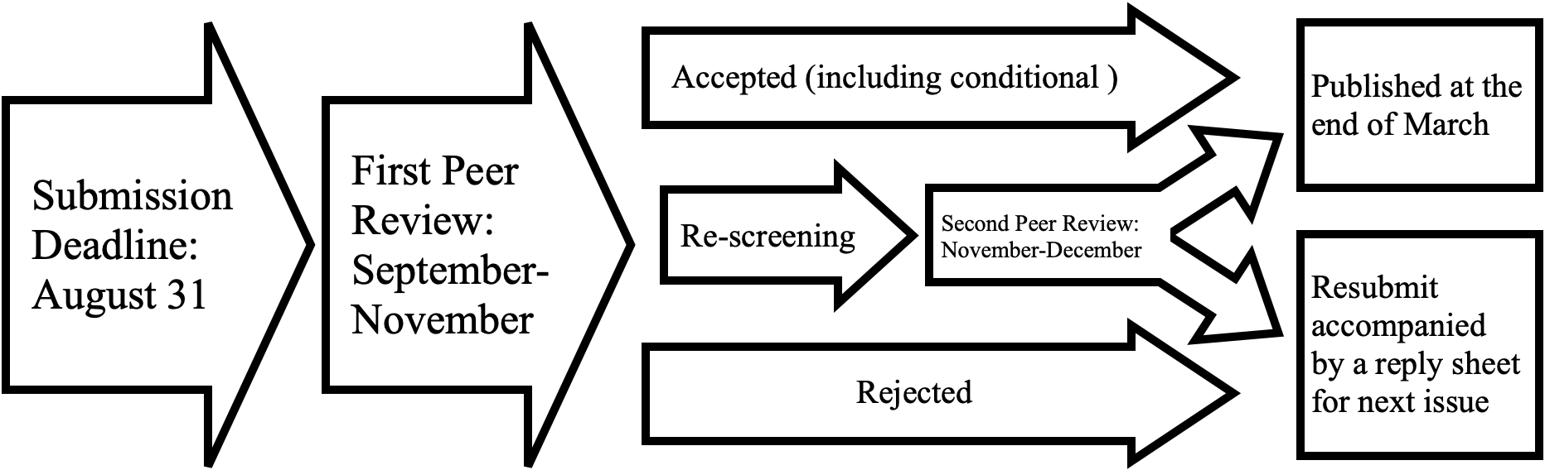
* Source: Editorial Committee of the Journal of the Japanese Educational Research Association, Educational Studies in Japan Paper Screening Guidelines

2.4 Ethical responsibilities
Importantly, prospective contributors are not allowed to submit a paper that has already been published in, or is currently under review by, any journal or book in English, Japanese, or any other language. If contributors have published, or submitted for publication, a paper on a subject closely related to that of their ESJ submission, they are requested to send it together with their manuscript to be reviewed. By the same token, a word-for-word English translation of a paper previously published in another language cannot be accepted, but an article that has been significantly modified and adapted to an English-language readership may be deemed acceptable: here too, the reviewers will need to see a copy of the original article.

Acknowledgments
Do not add acknowledgments until the paper is accepted. The overall word count may exceed 6,000 words when the acknowledgments are included after acceptance, but the acknowledgments should not exceed 10% of the total word count, allowing in addition for any corrections made in the review.

Notes
1. Any additional notes should be inserted as endnotes rather than footnotes, between the main body of the text and the list of references.
2. Endnote numbers should be superscripted thus,¹ consecutively in the text.

References
References should be listed after the text. Please follow the APA citation style. If the references include books or articles written in languages other than English, please indicate the original language of the publication at the end of each reference, as shown in the example below.

Kato, N. (1995). Amerika no Kage [The American Shadow]. Kodansha Gakujutsu Bunko (Japanese).
Standish, P. (2018). Shakai Seigi to Occident (Social Justice and the Occident). In Saito, N., Imai, Y., & Standish, P. (eds.), Honyaku no Sanaka ni Aru Shakai Seigi [Social Justice in Translation]. University of Tokyo Press (Japanese).
Ministry of Education, Culture, Sports, Science and Technology (MEXT). (2022). “Kyōshi busoku” ni kansuru jittai chōsa [Survey on the Actual Situation Regarding “Teacher Shortage”] (January 31, 2022). Available at: https://www.mext.go.jp/a_menu/shotou/kyoin/mext_00003.html [Accessed: September 9, 2024] (Japanese).

